Exercise 4_6 – 20 mins.

PTFL-4.2.5 (K4) Analyze throughput and concurrency when developing performance tests

Scenario:

An international travel website has embarked on a project to upgrade the flight booking functionality of its website. The current booking engine is slow and cumbersome.

The time currently measured for a customer on average to complete a booking is 5.7 minutes. Observations reveal that on average, a customer takes 35 seconds to enter data and click the button to proceed to the next step in the process.

You have the following information available to help plan performance tests:

- Network monitoring reports
- Web server monitoring reports
- Website analytics reports
- Server error logs
- Transaction reports which show the number of flights booked hourly each day

This information is compiled daily and displayed in a dashboard and also exported to a spreadsheet format as shown on the next page.

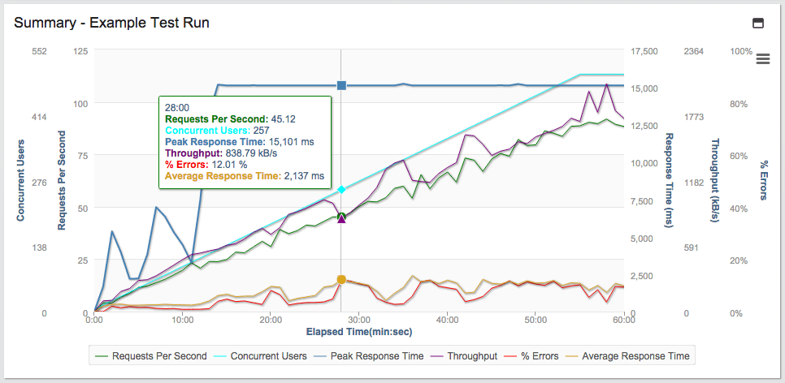

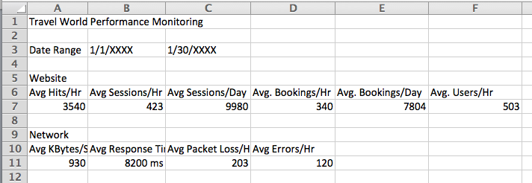

Analyze this information to determine throughput and concurrent usage of the current website.

It will be helpful to review syllabus section 4.2.5 to determine these.

Throughput:

Concurrent usage:

Question: Can you see other ways to express throughput?

